Reims Tram

Exploratory Data Analysis

# Raw Data

## Data Description

Tole lepše napišita na podlagi ostalih dokumentov.

* CH1 – external temperature
* CH2 – internal temperature
* CH3 – lon
* CH4 – lat
* CH5 – system pressure drop in HVAC – not interesting
* CH6 – speed in km/h
* CH7, CH20 – HVAC current
* CH8, 9 – traction currents – sila na vlak
* CH10 – CO2 level, they don’t know accuracy, they don’t know the number of pasasgners
* CH11 – CH14 – current in the rheostat – we get power from the top during the itinerary, in centere there are 2 km, where instead of third track we get power from the ground
  + when the tram is breaking the kinetic energy is recovered and reinserted into the line to be used to other tram in the same substation, recharge battery; when it is powered through the ground – the kinetic energy is dicipated into rheostat, rheostaet measures the dicipation of the energy
* CH15 – above 12V we have overhead, otherwise ground – napetost – just indication where power comes from
* Power of the line:
  + CH16 – current of the overhead line – when the tram goes forward, the current is negative (using energy), when it is recovering – the current is positve
  + CH17 – voltage
* CH18 – current of power converter – converts DC to AC and is used to feed the current back into the line, to convert the current to feed the heating and ventilation
* Ch19 – for this
* CH20 – other current for the heating

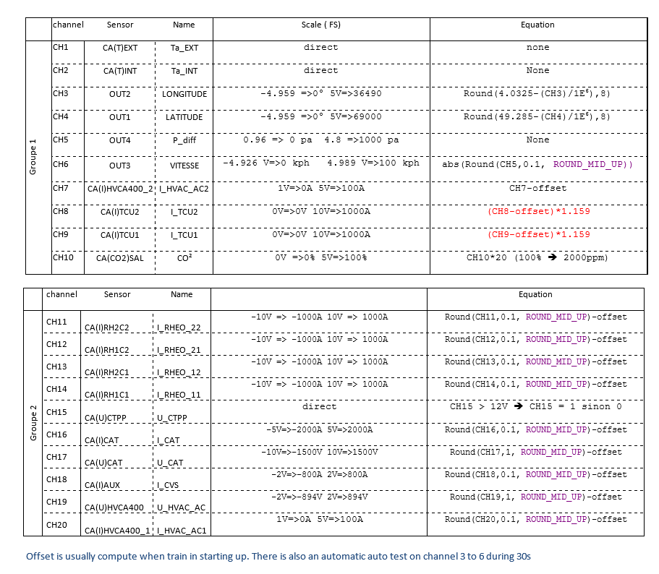

Figure 1: Table of ???

We need to calculate the following offsets:

* CH7-14
* CH16-20

## Pre-processing

* kakšen SW smo uporabili
* kako smo podatke naložili
* kakšne fajle smo dobili in kako smo jih predelali (odstranili header)
* kaj smo naredili s time stampi, kako smo pretvorili stringe v floate?

# Learning Calibration Parameters

## Calibration Procedure Description

* opis, kako poračunamo offsete (prvih 30s, povprečja)

## Finding Calibration Parameters (Offsets)

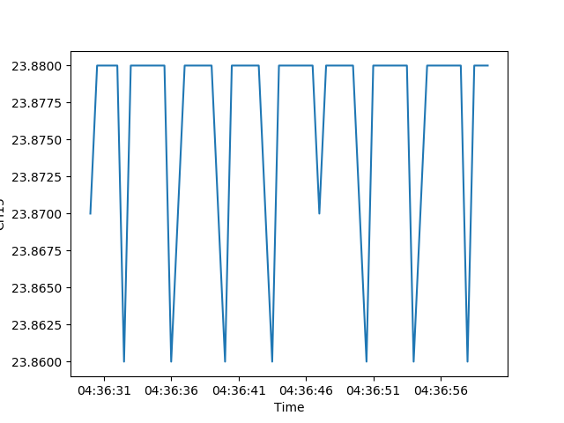

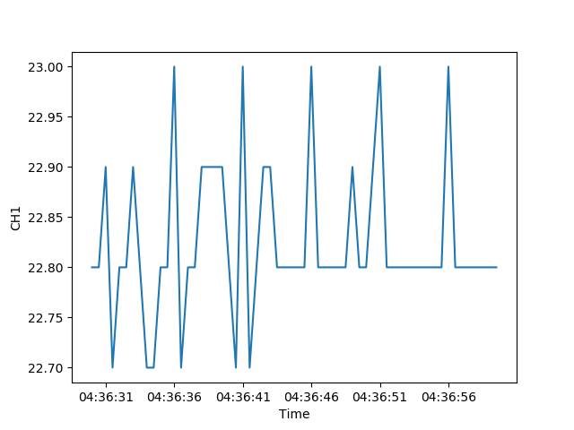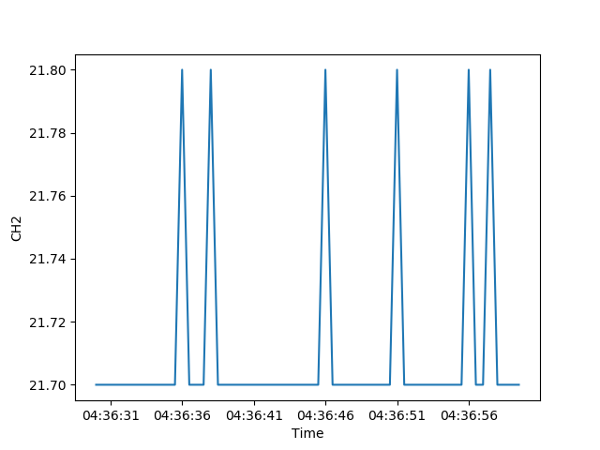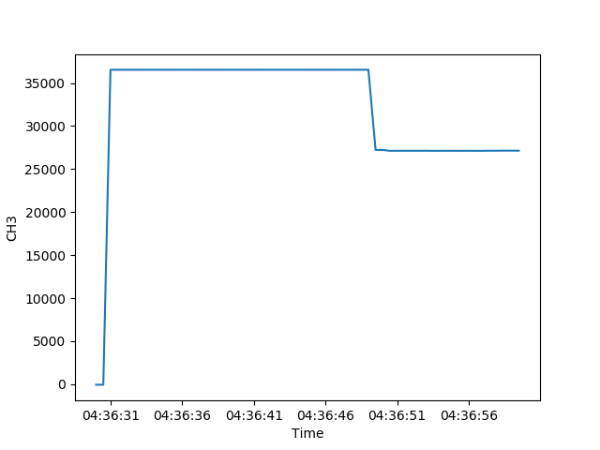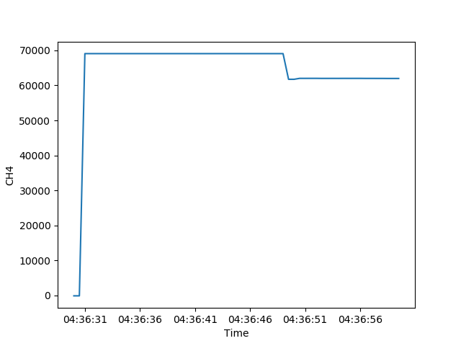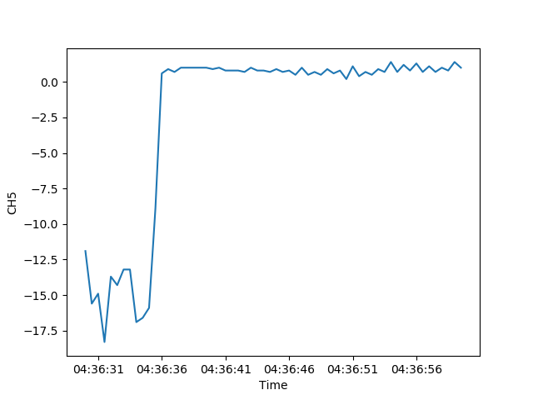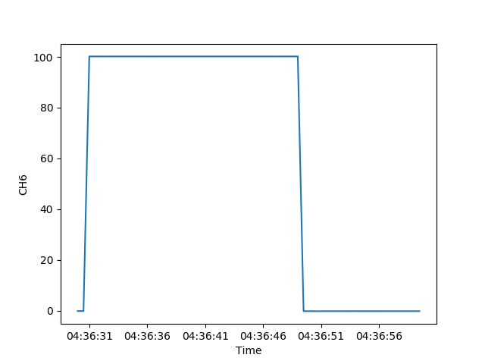

Figure 3: External and internal temperature (in °C) – first two, 4 sensors with automatic start-up test procedures: latitude, longitude, pressure and speed and 1 sensor for voltage U_CTPP. These sensors don’t need their offset calculated.

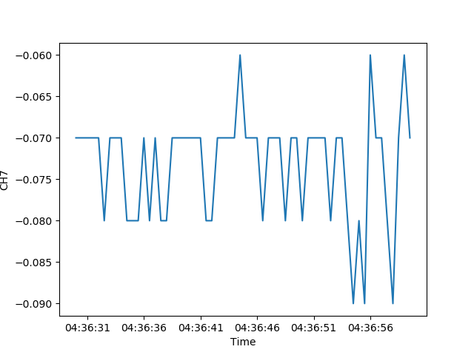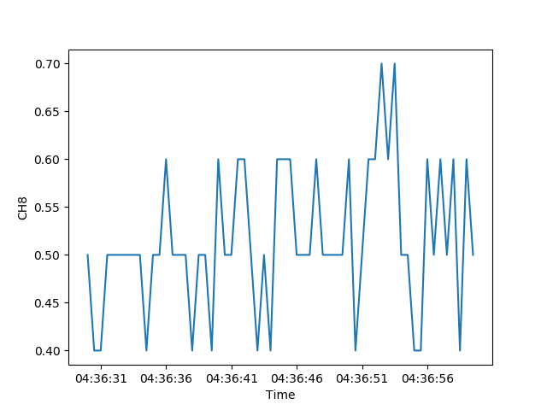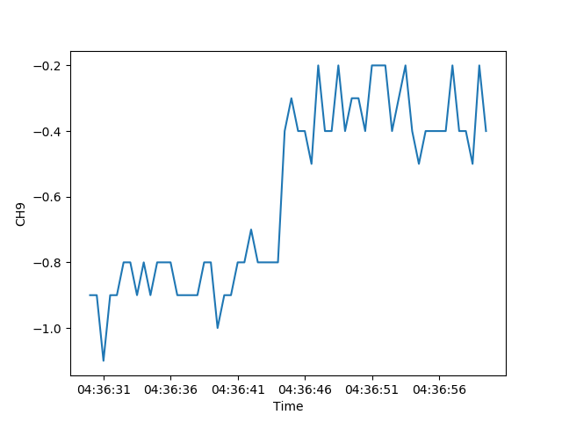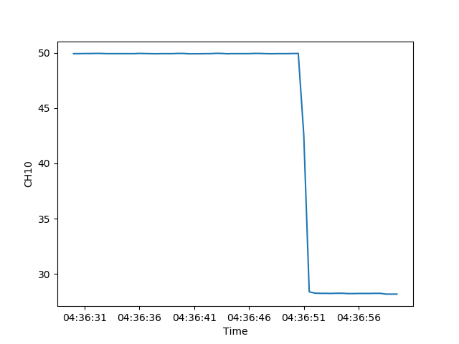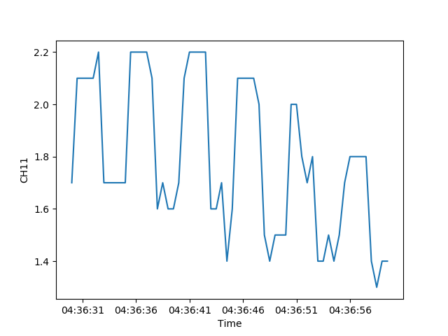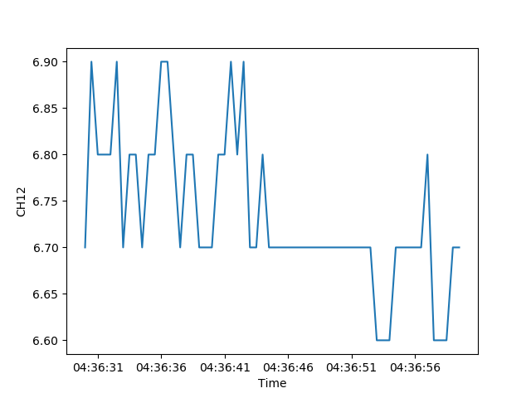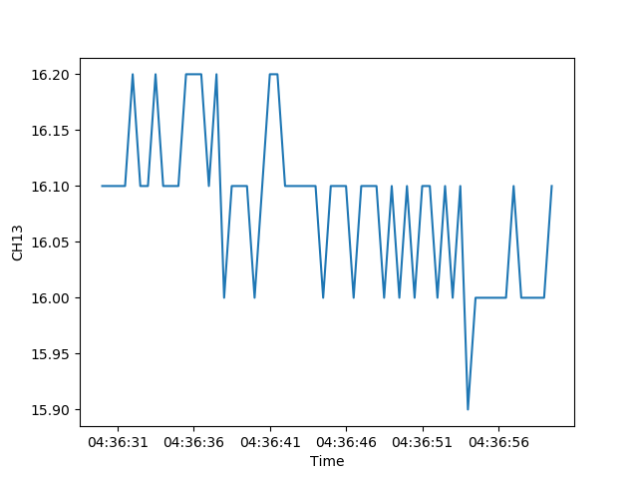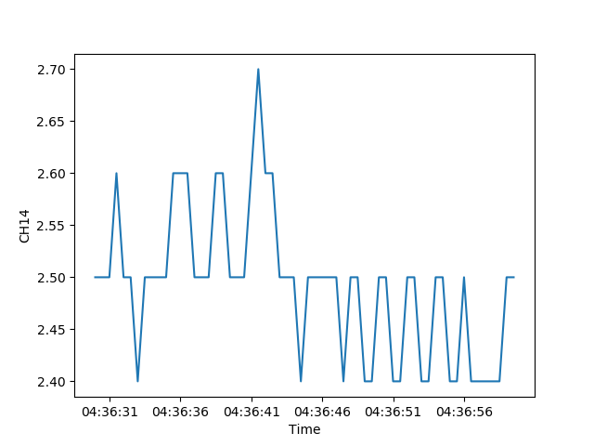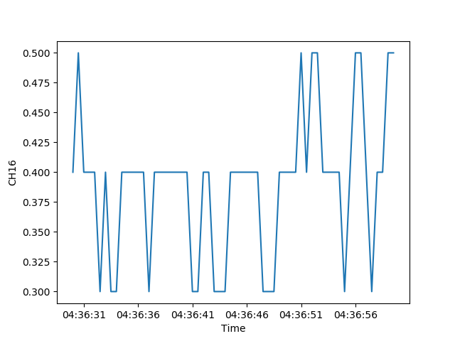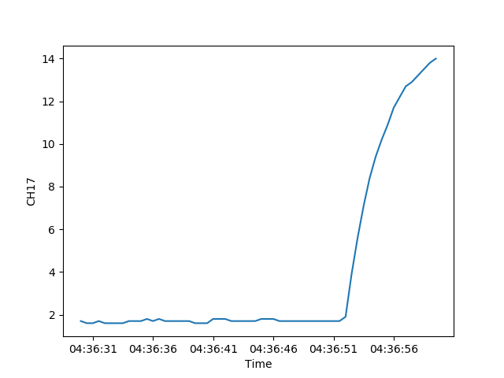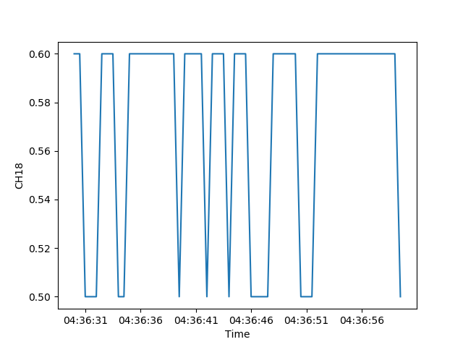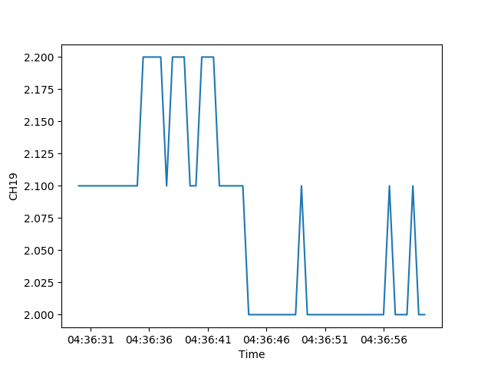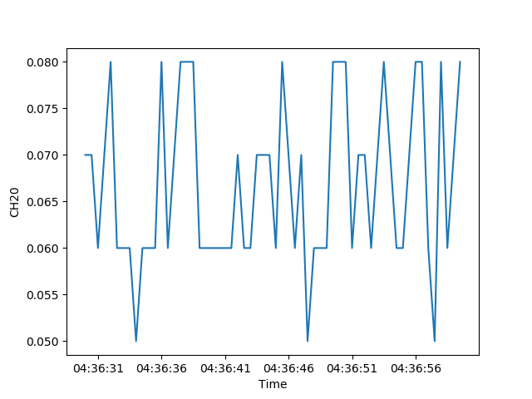

Figure 4: Sensors for which calibration is needed (taking average from the first 30s). We can observe problematic sensors on CH9, CH10, CH11 and CH17 (marked with yellow border).

Komentirajata ločljivost posamičnih senzorjev. Kateri je boljši, kateri slabši?

Tabela z rezultati po posamičnih senzorjih – lahko iste skupine, kot pri grafih (min, max, avg, stdev). Primerjava std in dejstva, da nek senzor ni v “stacionarnem stanju”. Bi lahko na podlagi tega naredili neko detekcijo, kateri senzor je “fail”-al in ga ni mogoče inicializirati?